PL SQL programming

Exercise 1: Control Structures

Scenario 1: The bank wants to apply a discount to loan interest rates for customers above 60 years old.
  - Question: Write a PL/SQL block that loops through all customers, checks their age, and if they are above 60, apply a 1% discount to their current loan interest rates.
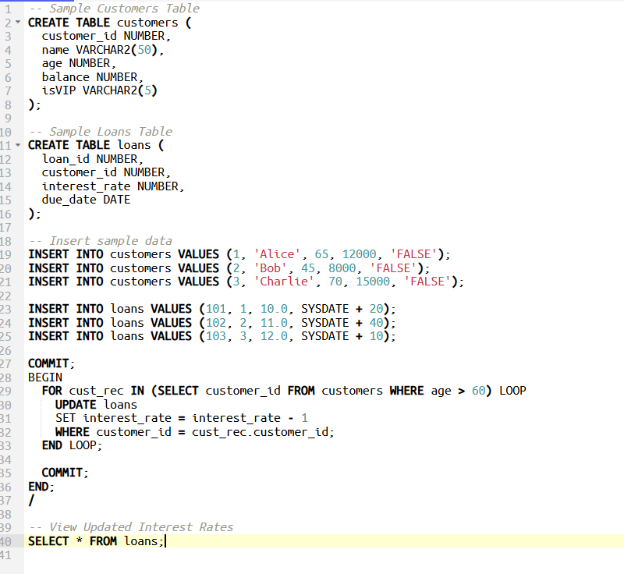
Output :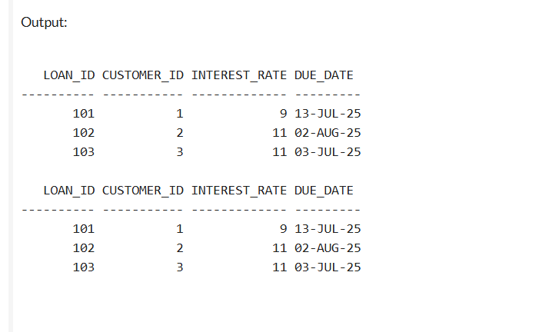

Scenario 2: A customer can be promoted to VIP status based on their balance.
Question: Write a PL/SQL block that iterates through all customers and sets a flag IsVIP to TRUE for those with a balance over $10,000
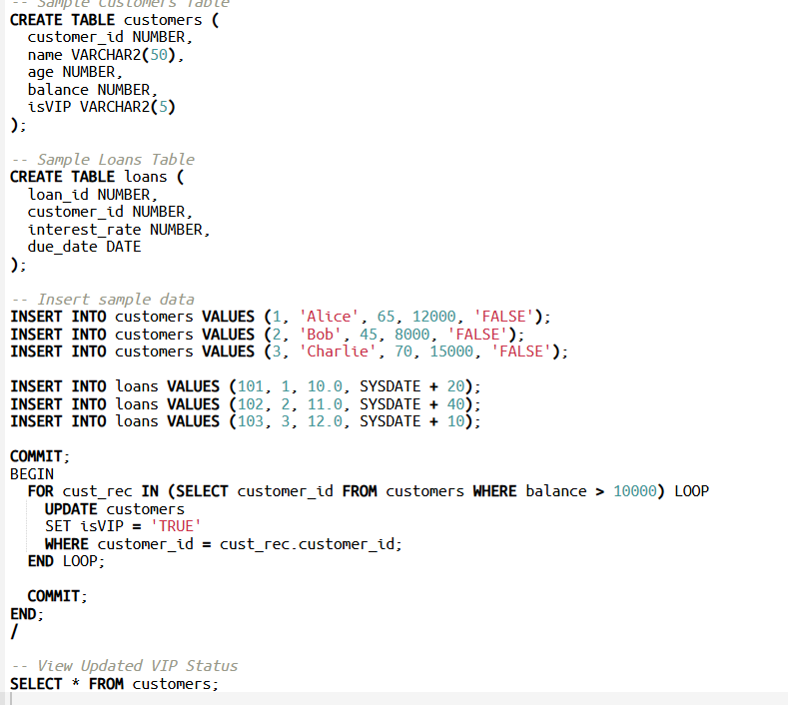

Output :

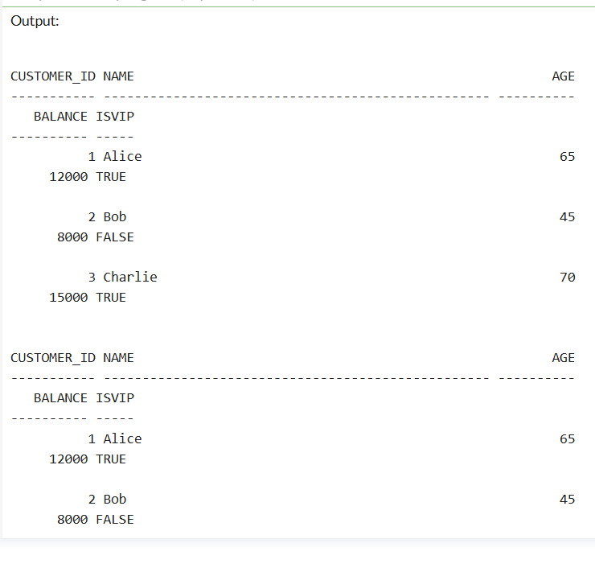
Scenario 3: The bank wants to send reminders to customers whose loans are due within the next 30 days.
  - Question: Write a PL/SQL block that fetches all loans due in the next 30 days and prints a reminder message for each customer.
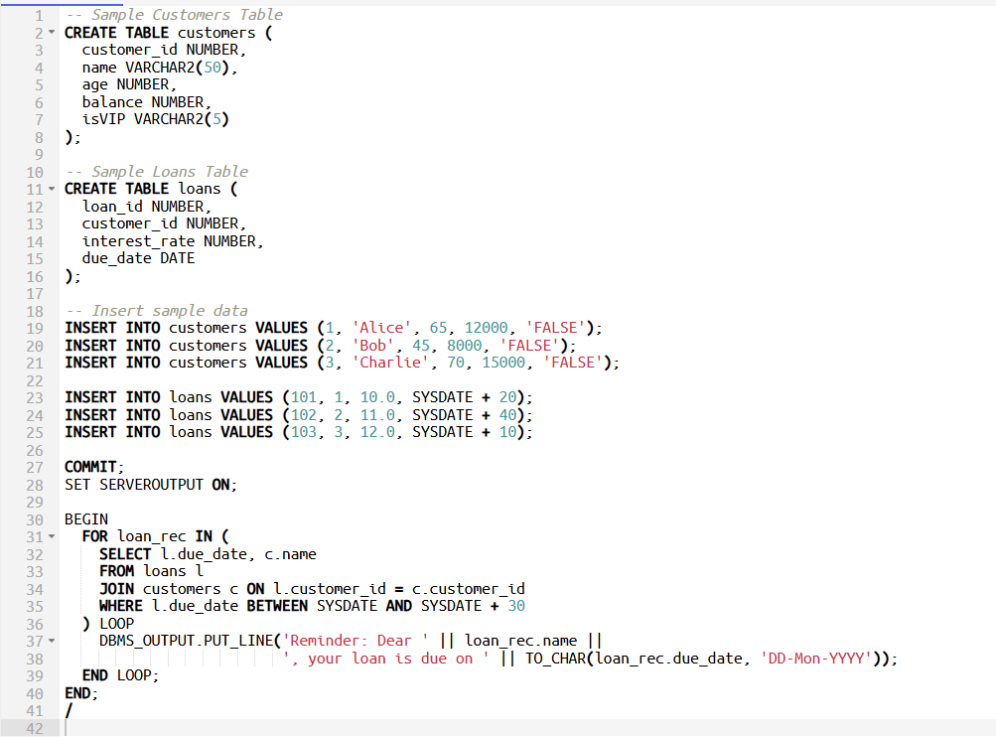

Output :

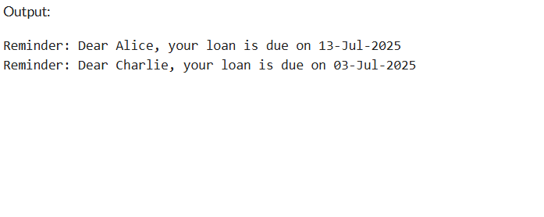
Exercise 3: Stored Procedures

Scenario 1: The bank needs to process monthly interest for all savings accounts.
  - Question: Write a stored procedure ProcessMonthlyInterest that calculates and updates the balance of all savings accounts by applying an interest rate of 1% to the current balance.
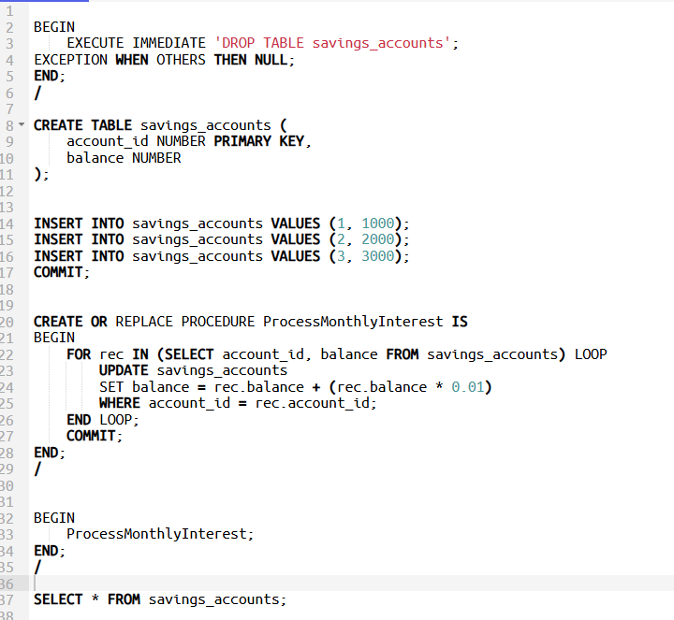
Output :
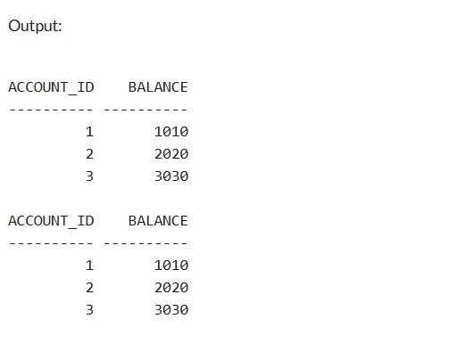
Scenario 2: The bank wants to implement a bonus scheme for employees based on their performance.
  - Question: Write a stored procedure UpdateEmployeeBonus that updates the salary of employees in a given department by adding a bonus percentage passed as a parameter.
  - 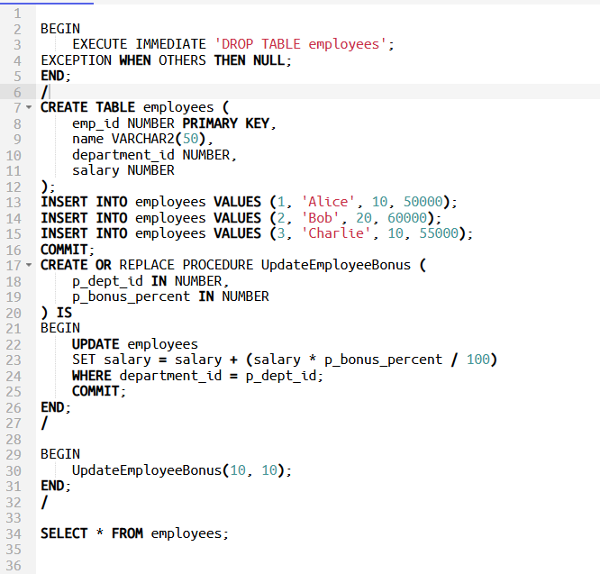
Output :
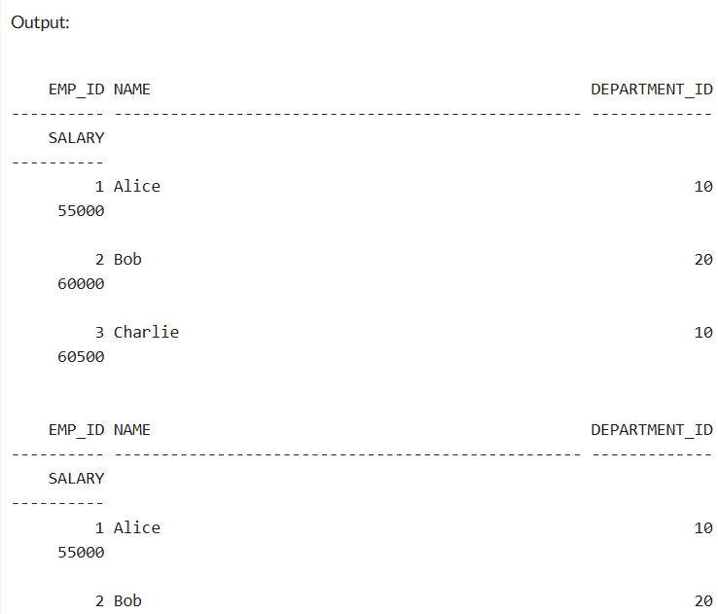
Scenario 3: Customers should be able to transfer funds between their accounts.
  - Question: Write a stored procedure TransferFunds that transfers a specified amount from one account to another, checking that the source account has sufficient balance before making the transfer.
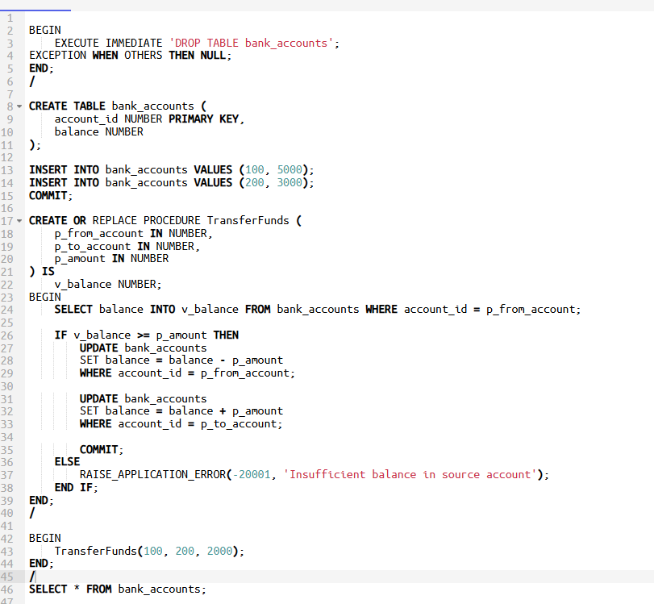

output :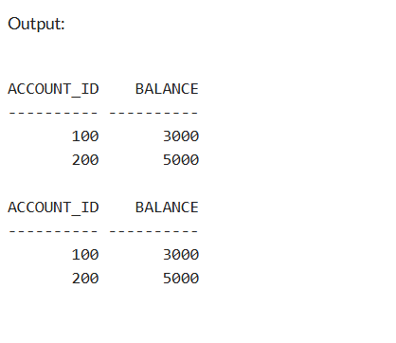
TDD using JUnit5 and Mockito
Exercise 1: Setting Up Junit
Calculator
public class Calculator {
public int add(int a, int b) {
return a + b;
}
}
CalculatorTest
import org.junit.Test;
import static org.junit.Assert.*;

public class CalculatorTest {
@Test
public void testAdd() {
Calculator calc = new Calculator();
assertEquals(5, calc.add(2, 3));
}
}

Exercise 3: Assertions in Junit

import org.junit.Test;
import static org.junit.Assert.*;

public class AssertionsTest {

@Test
public void testAssertions() {
// Assert equals
assertEquals(5, 2 + 3);

// Assert true
assertTrue(5 > 3);

// Assert false
assertFalse(5 < 3);

// Assert null
assertNull(null);

// Assert not null
assertNotNull(new Object());
}
}
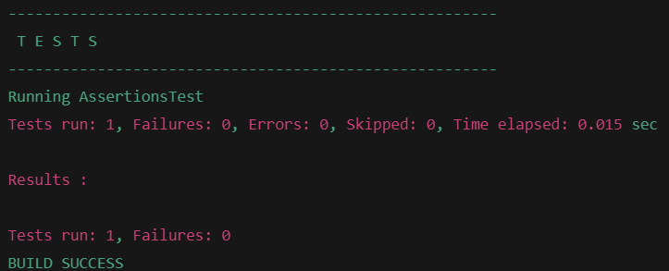

Exercise 4: Arrange-Act-Assert (AAA) Pattern, Test Fixtures, Setup and
Teardown Methods in JUnit

import static org.junit.Assert.*;
import org.junit.Before;
import org.junit.After;
import org.junit.Test;

class Calculator {
public int add(int a, int b) {
return a + b;
}

public int subtract(int a, int b) {
return a - b;
}
}

public class CalculatorTest {

private Calculator calculator;

@Before
public void setUp() {
calculator = new Calculator(); // Arrange
System.out.println("Setup: Calculator instance created.");
}

@After
public void tearDown() {
calculator = null;
System.out.println("Teardown: Calculator instance set to null.\n");
}

@Test
public void testAddition() {
// Arrange is done in @Before

// Act
int result = calculator.add(10, 5);

assertEquals(15, result);
}

@Test
public void testSubtraction() {
int result = calculator.subtract(10, 3);

assertEquals(7, result);
}
}

Output :
Setup: Calculator instance created.
Teardown: Calculator instance set to null.

Setup: Calculator instance created.
Teardown: Calculator instance set to null.

Tests run: 2, Failures: 0

Exercise 1: Mocking and Stubbing

ExternalApi.java
package com.example;

public interface ExternalApi {
String getData();
}
MyService.java
package com.example;

public class MyService {
private final ExternalApi externalApi;

public MyService(ExternalApi externalApi) {
this.externalApi = externalApi;
}

public String fetchData() {
return externalApi.getData();
}
}

MyServiceTest.java
package com.example;

import org.junit.jupiter.api.Test;
import static org.junit.jupiter.api.Assertions.assertEquals;
import static org.mockito.Mockito.*;

public class MyServiceTest {

@Test
public void testExternalApi() {
// Step 1: Create mock
ExternalApi mockApi = mock(ExternalApi.class);

when(mockApi.getData()).thenReturn("Mock Data");

MyService service = new MyService(mockApi);
String result = service.fetchData();

assertEquals("Mock Data", result);
}
}

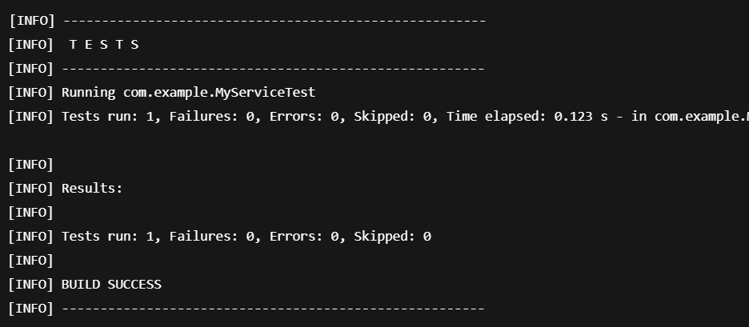

Exercise 2: Verifying Interactions
import static org.mockito.Mockito.*;
import org.junit.jupiter.api.Test;
import org.mockito.Mockito;

interface ExternalApi {
void getData();
}

class MyService {
private ExternalApi api;

public MyService(ExternalApi api) {
this.api = api;
}

public void fetchData() {
api.getData(); // This is what we want to verify
}
}

public class MyServiceTest {

@Test
public void testVerifyInteraction() {

ExternalApi mockApi = Mockito.mock(ExternalApi.class);

MyService service = new MyService(mockApi);
service.fetchData();

verify(mockApi).getData();
}
}

OUTPUT :

BUILD SUCCESSFUL
Tests run: 1, Failures: 0
SLF4J logging framework
Exercise 1: Logging Error Messages and Warning Levels

import org.slf4j.Logger;
import org.slf4j.LoggerFactory;

public class LoggingExample {
private static final Logger logger = LoggerFactory.getLogger(LoggingExample.class);

public static void main(String[] args) {
logger.error("This is an error message");
logger.warn("This is a warning message");
}
}
OUTPUT :
13:45:10.123 [main] ERROR LoggingExample - This is an error message
13:45:10.125 [main] WARN LoggingExample - This is a warning message

